Dr. Parul Singh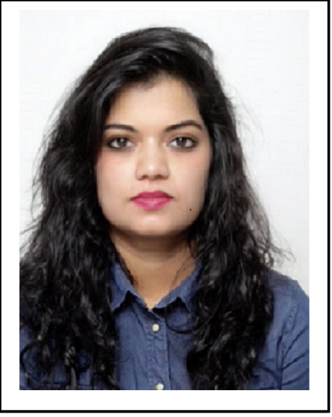

**Name:** Dr. Parul Singh

**Affiliation:** Assistant Professor, Department of Sociology,

Government Arts Girls College, University of Kota,

Kota 324001

**Contact Number:** 9783366209

**E-mail ID:** [spparulsingh@gmail.com](mailto:spparulsingh@gmail.com)

Parul Singh is an Assistant Professor in the department of Sociology, Government Arts Girls College, Kota. In her 10 years Teaching Experience. She has several Research Articles, transcriptions and Book reviews published. Her research interest includes Urban Sociology, Gender Studies, Sociology of Family and Kinship in India and Sustainable development.

She is actively associated with RSA Since a decade and also a member of Indian Sociological Society. She was Assistant Editor of Rajasthan Journal of Sociology issue XIII and has also previously edited a volume of RSA E-Newsletter. She organized First Young Writers’ regional workshop of RSA and faculty development programs like GYANDOOT and GYANGANGA assigned by directorate college education. She has Presented Papers in more than 25 National, International Conferences, Seminars and Webinars on Different Topics and Participated in more than 30 National, International Conferences, Seminars and Webinars. She Convened **GYANDOOT** Program Phase-1 of Sociology under the supervision of Commissionerate College Education Rajasthan, Jaipur during June-July, 2021.